Elekta Shutdown

# Purpose

This is a detailed version of the [Elekta shutdown procedure](https://crmc.policystat.com/v2/policy/6084087/latest/) on the intranet.

# Steps

1. Shut off iView computer (rightmost computer at Elekta console).
   1. Log out of XVI.
      1. Click **Patient**.
      2. Click **Logout**.

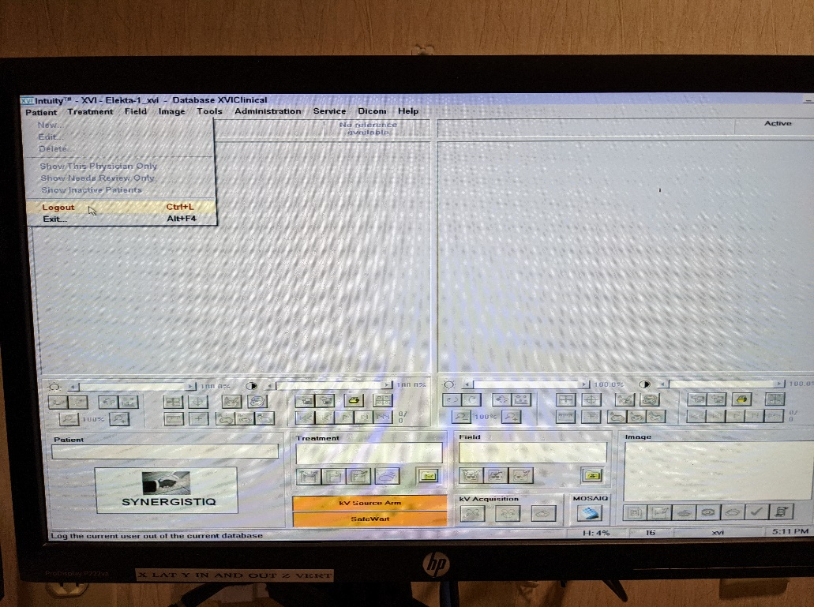

* 1. Exit XVI.
     1. Click **Exit…**.

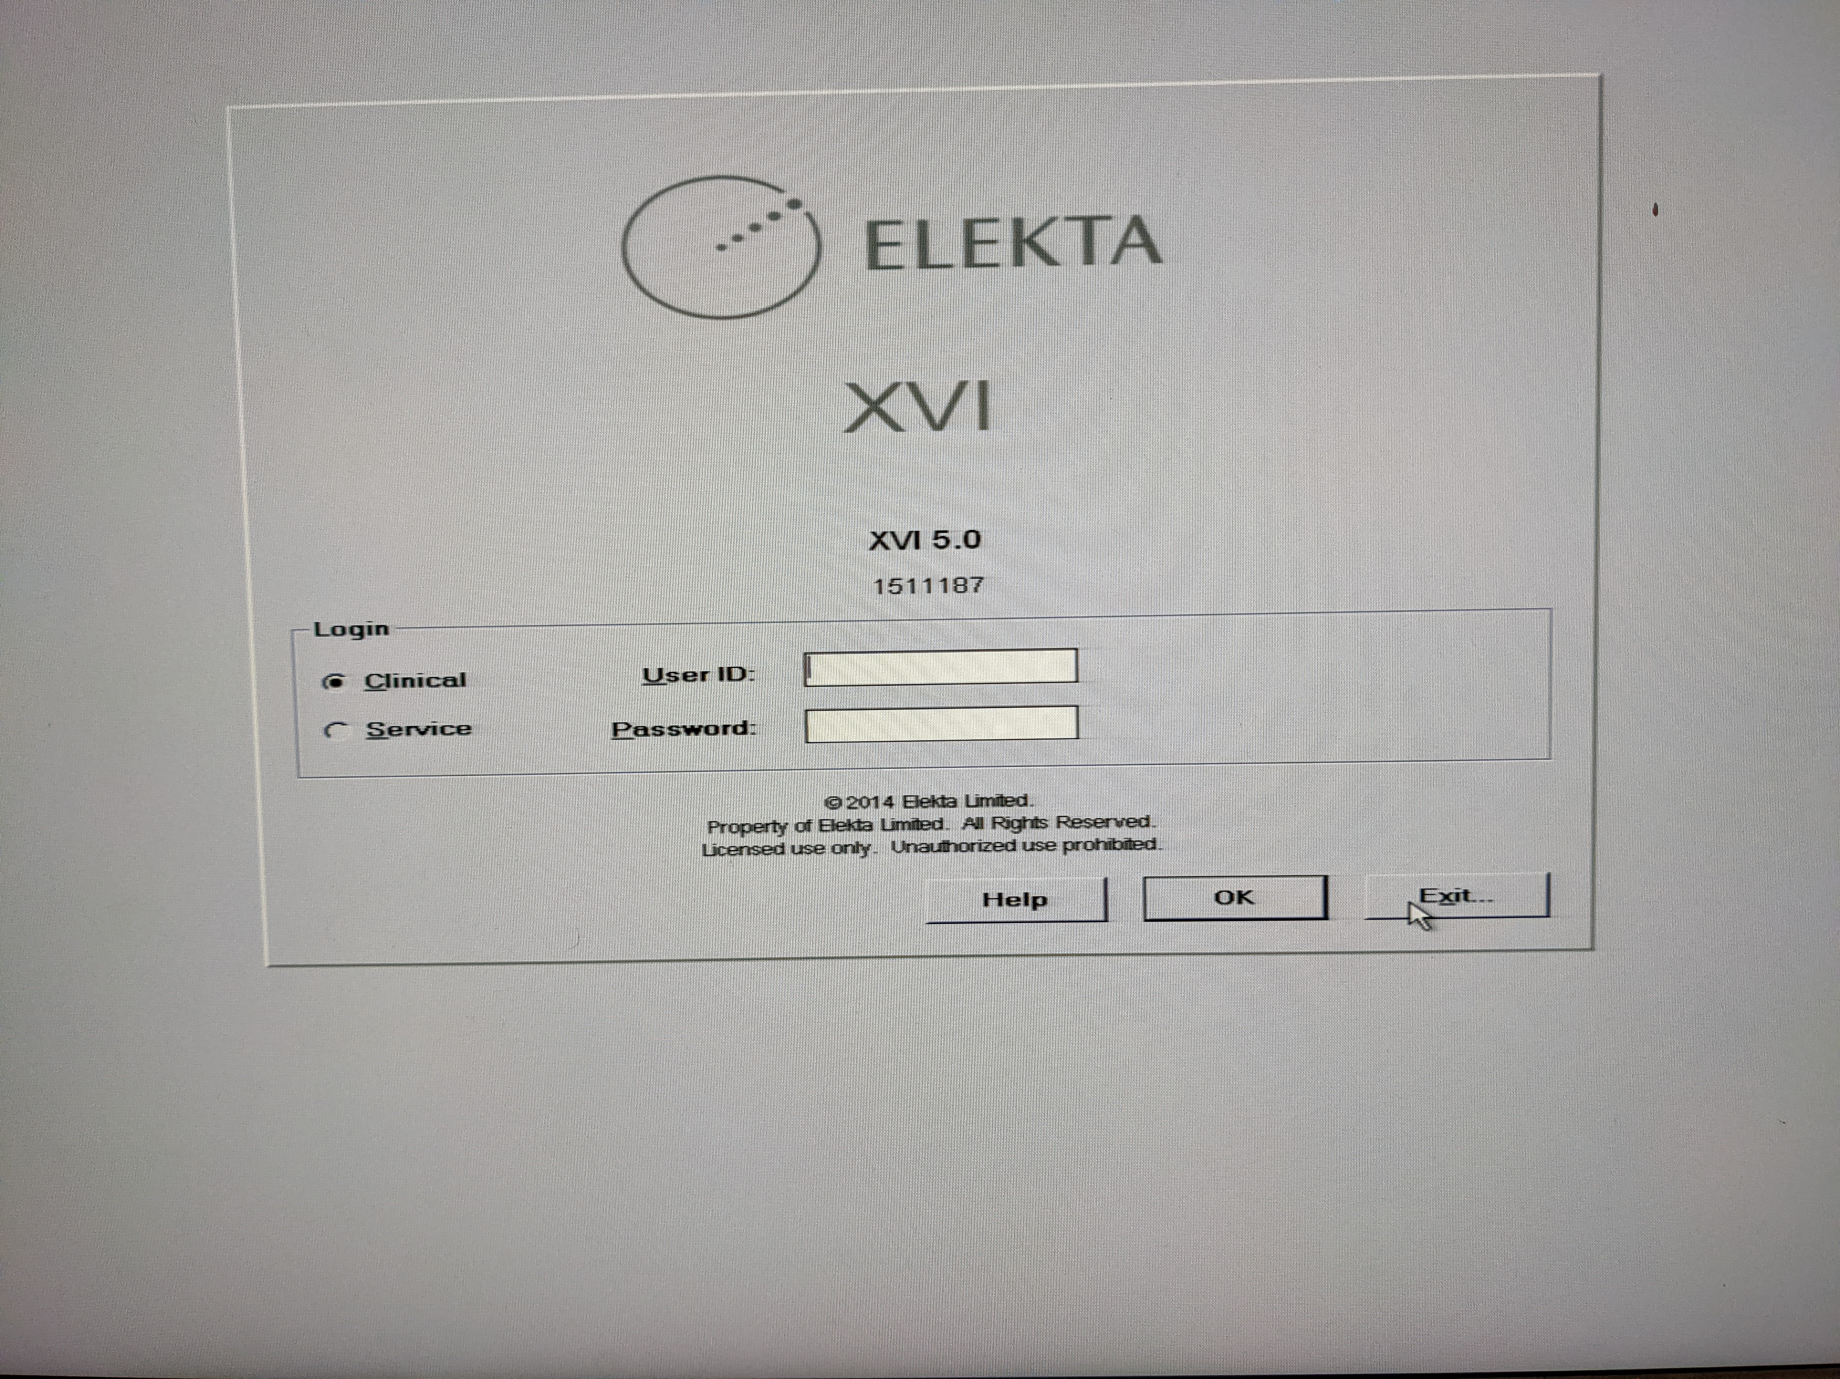

* + 1. Click **Yes**.

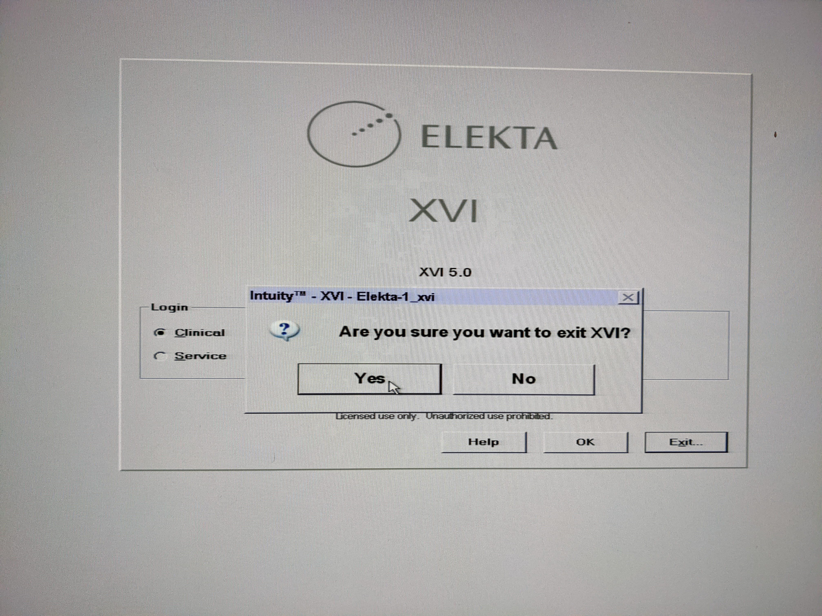

* 1. If it is Friday, shut down the computer.

Otherwise, just turn off the monitor.

Ignore the **Power Button Lockout** error if it appears.

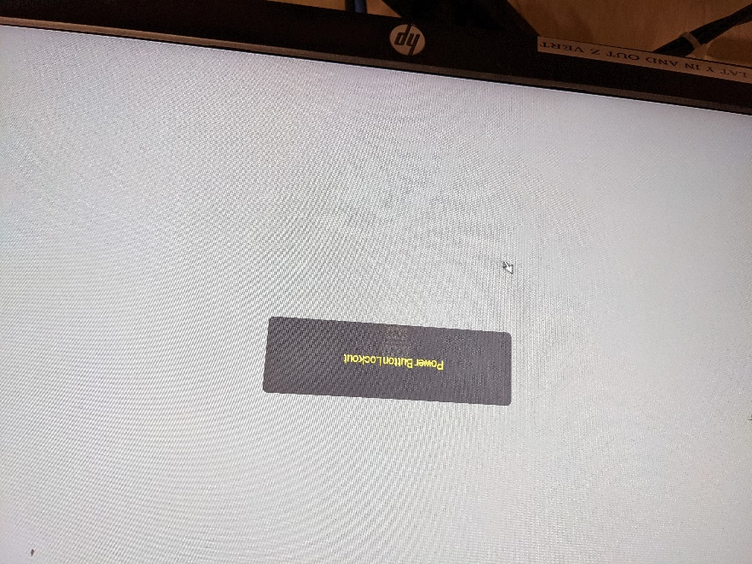

1. Shut off MOSAIQ computer (middle computer at Elekta console).
   1. Log out of MOSAIQ.
      1. Click **File**.
      2. Click **Logout**.

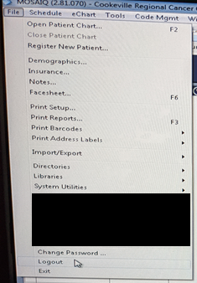

* 1. Exit MOSAIQ.
     1. Click **File**.
     2. Click **Logout**.

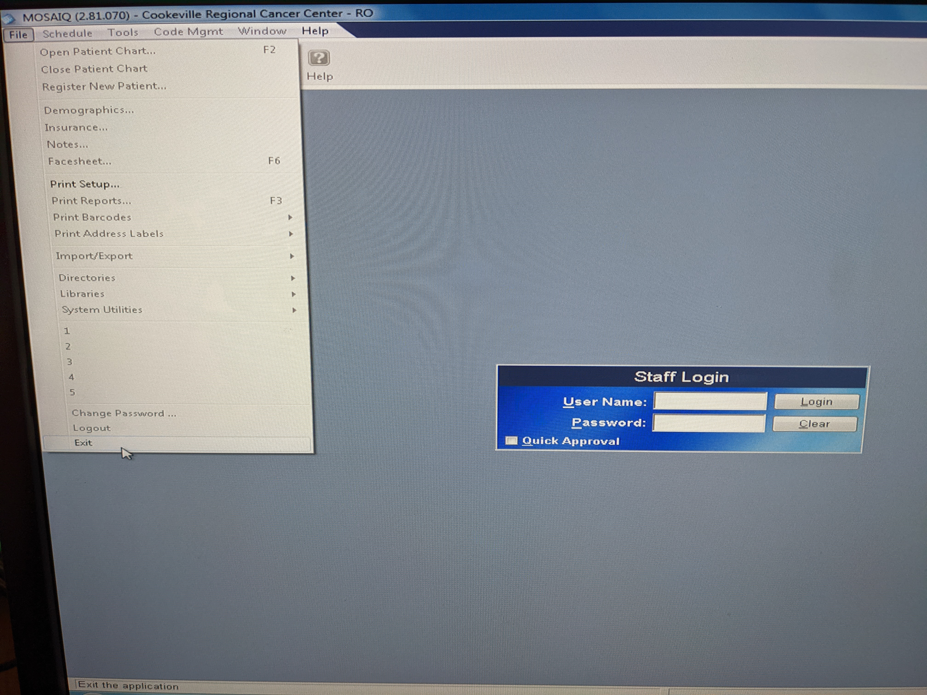

* 1. Shut down computer.
     1. Click Windows Start button.

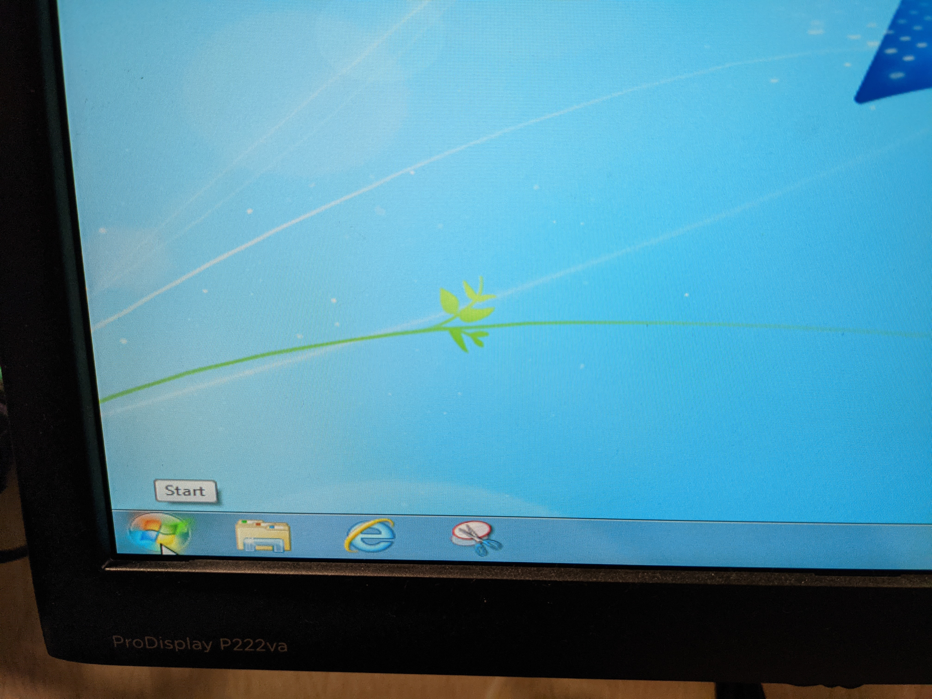

* + 1. Click **Shut down**.

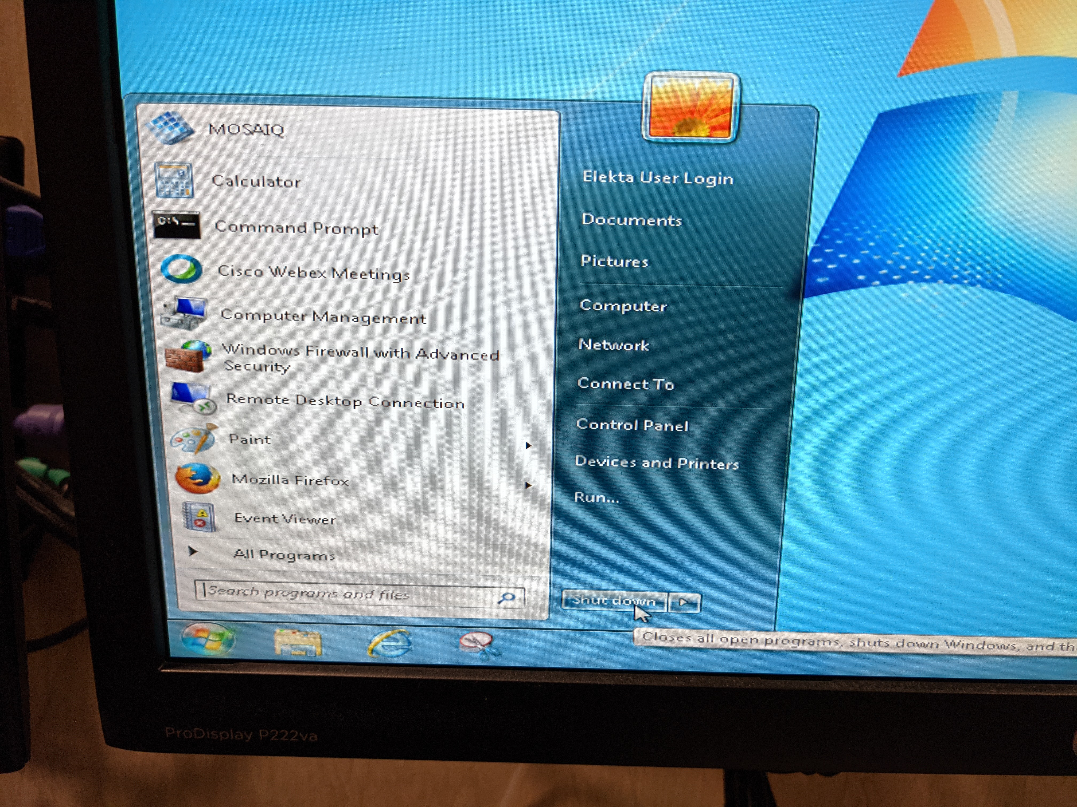

1. Shut off linac computer (leftmost computer at Elekta console).
   1. Click **Exit**.

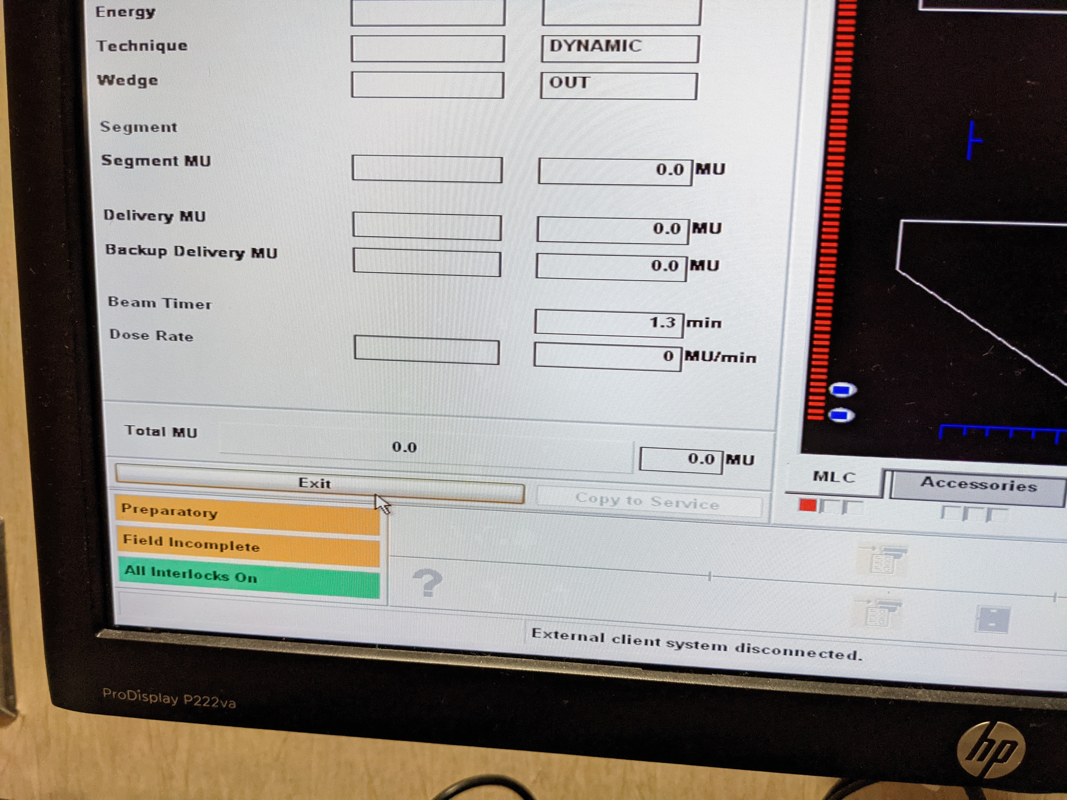

* 1. Log out.
     1. Click **Log out** button.

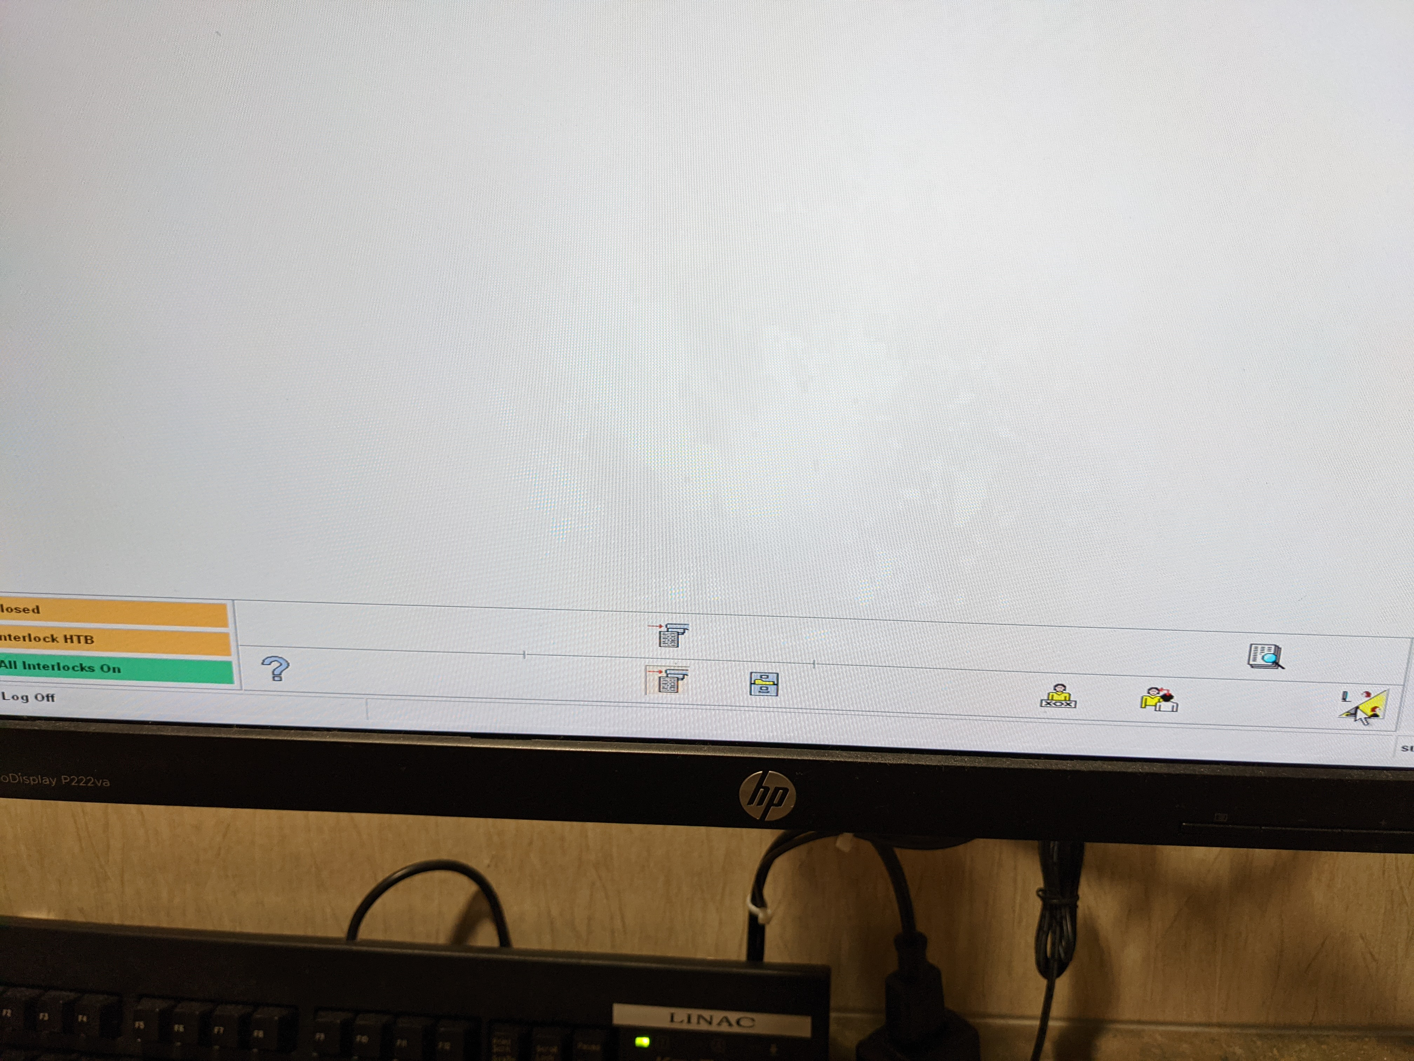

* + 1. Click **Yes**.

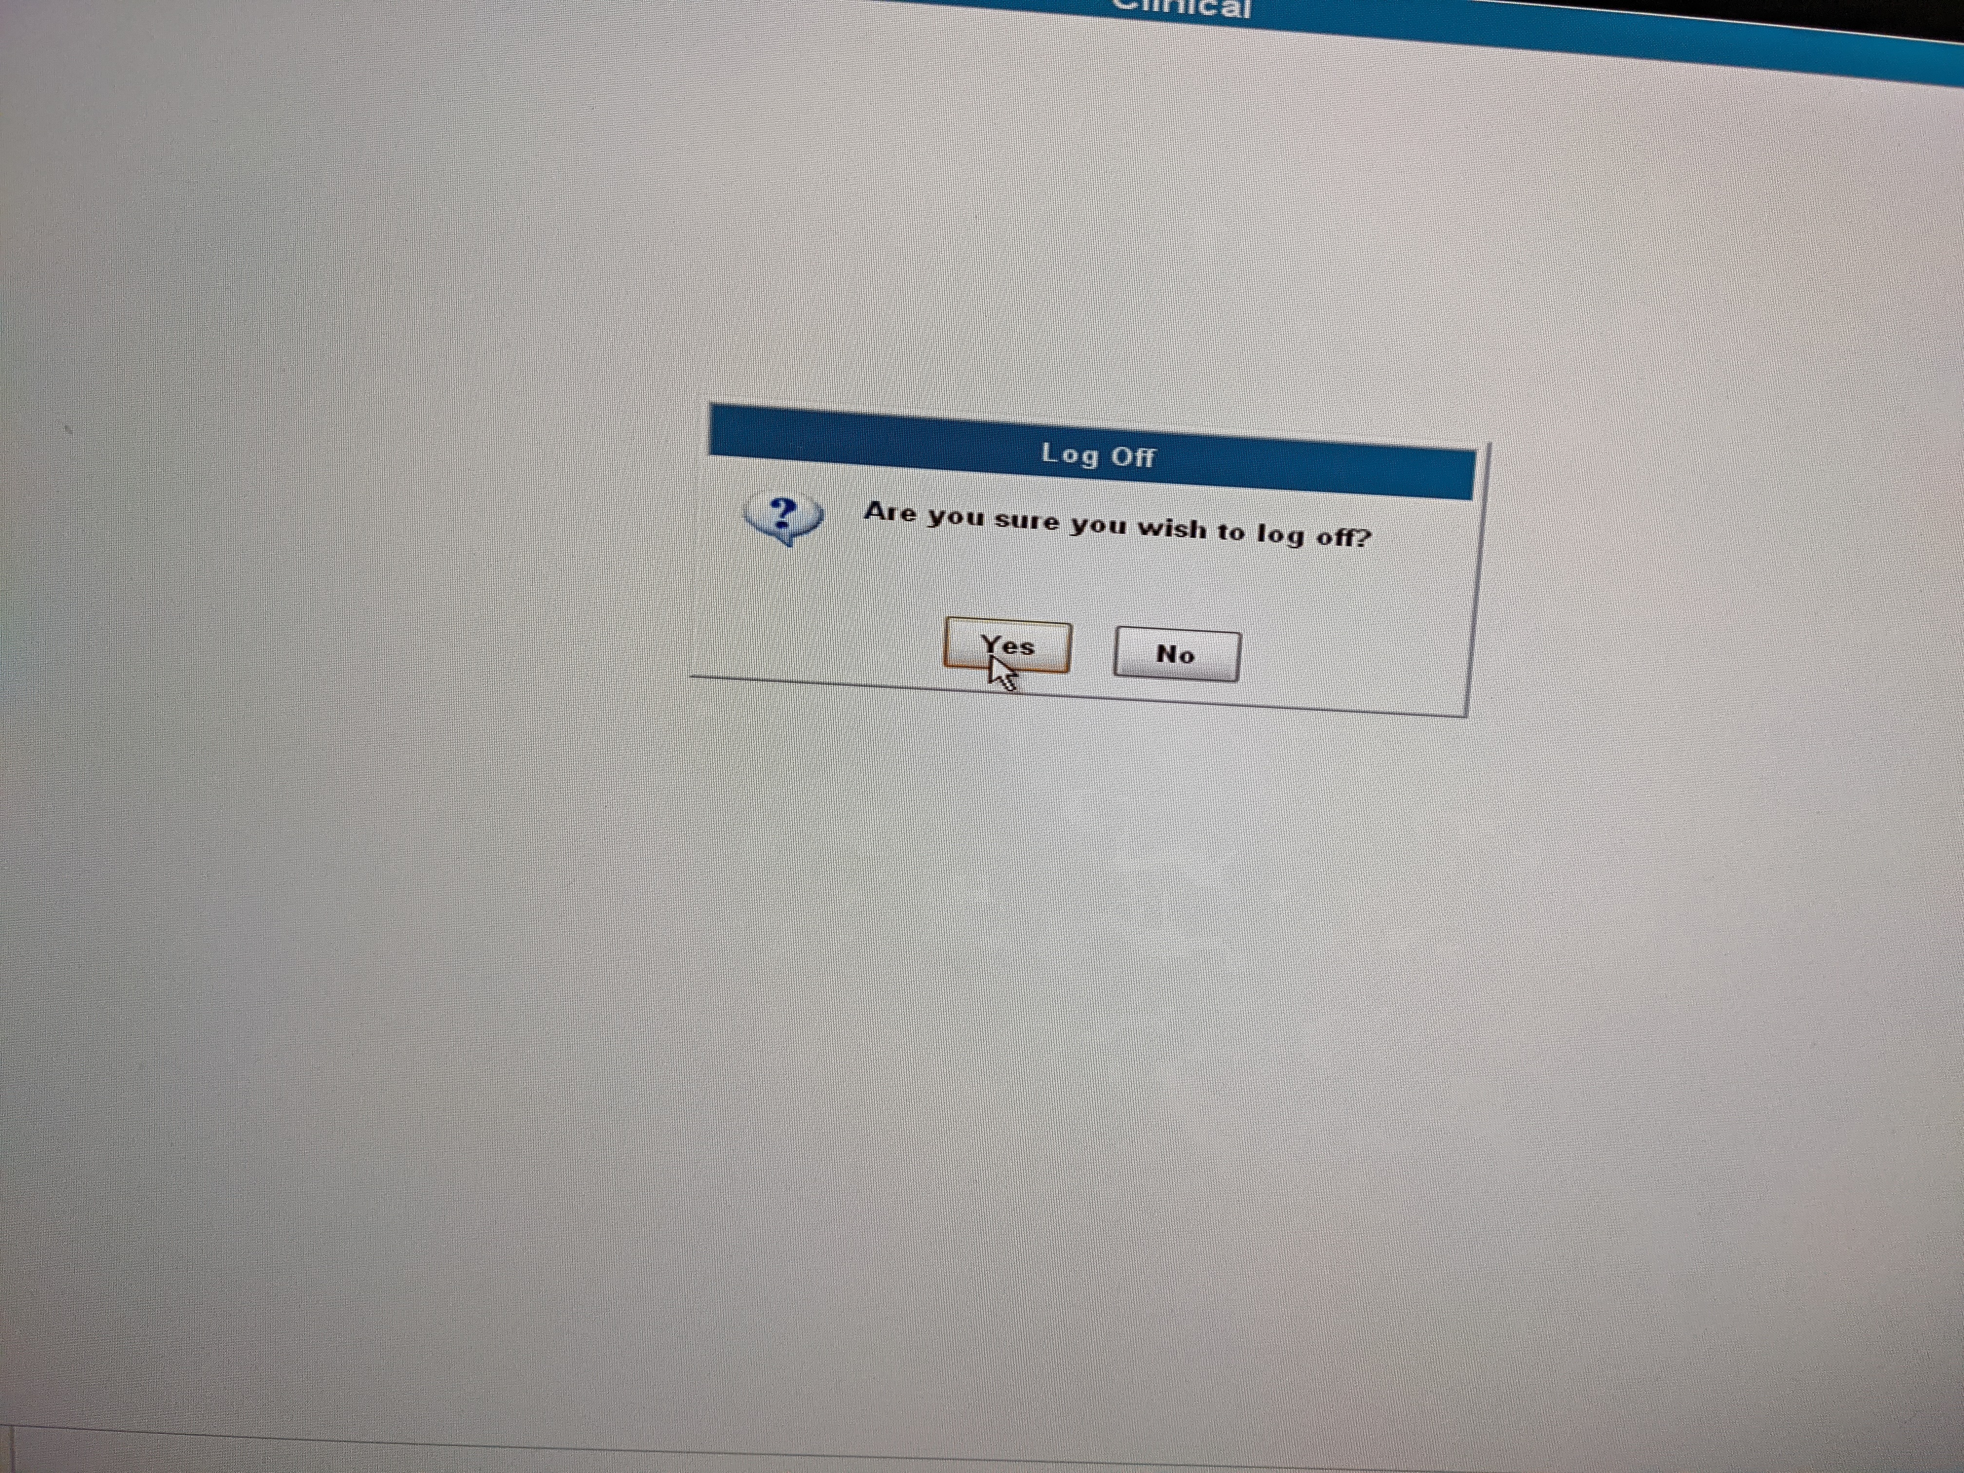

* 1. Shut down computer.
     1. Click **Shutdown**.

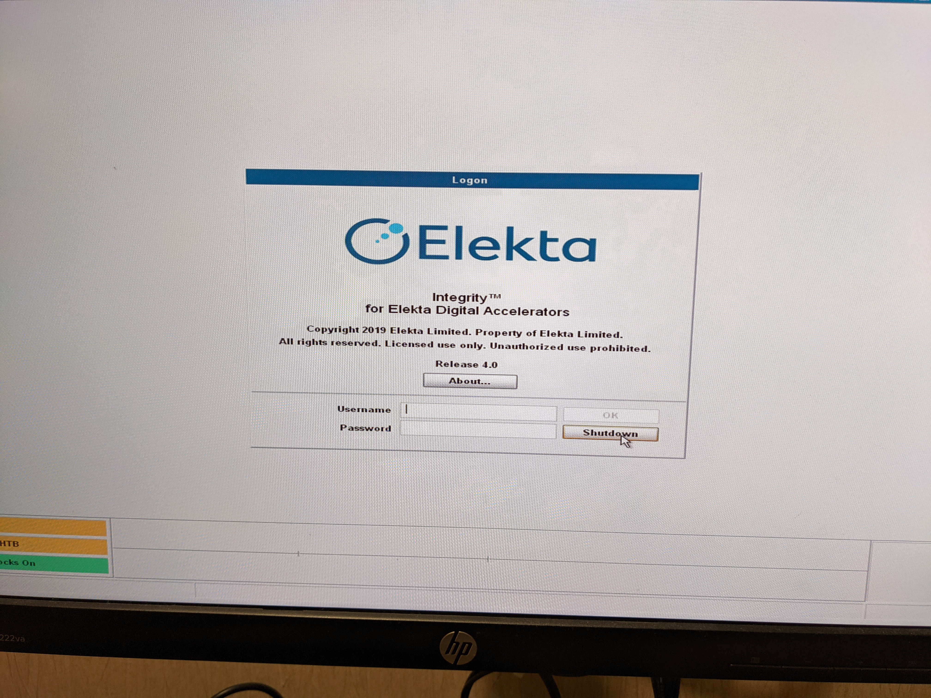

* + 1. Click **Yes**.

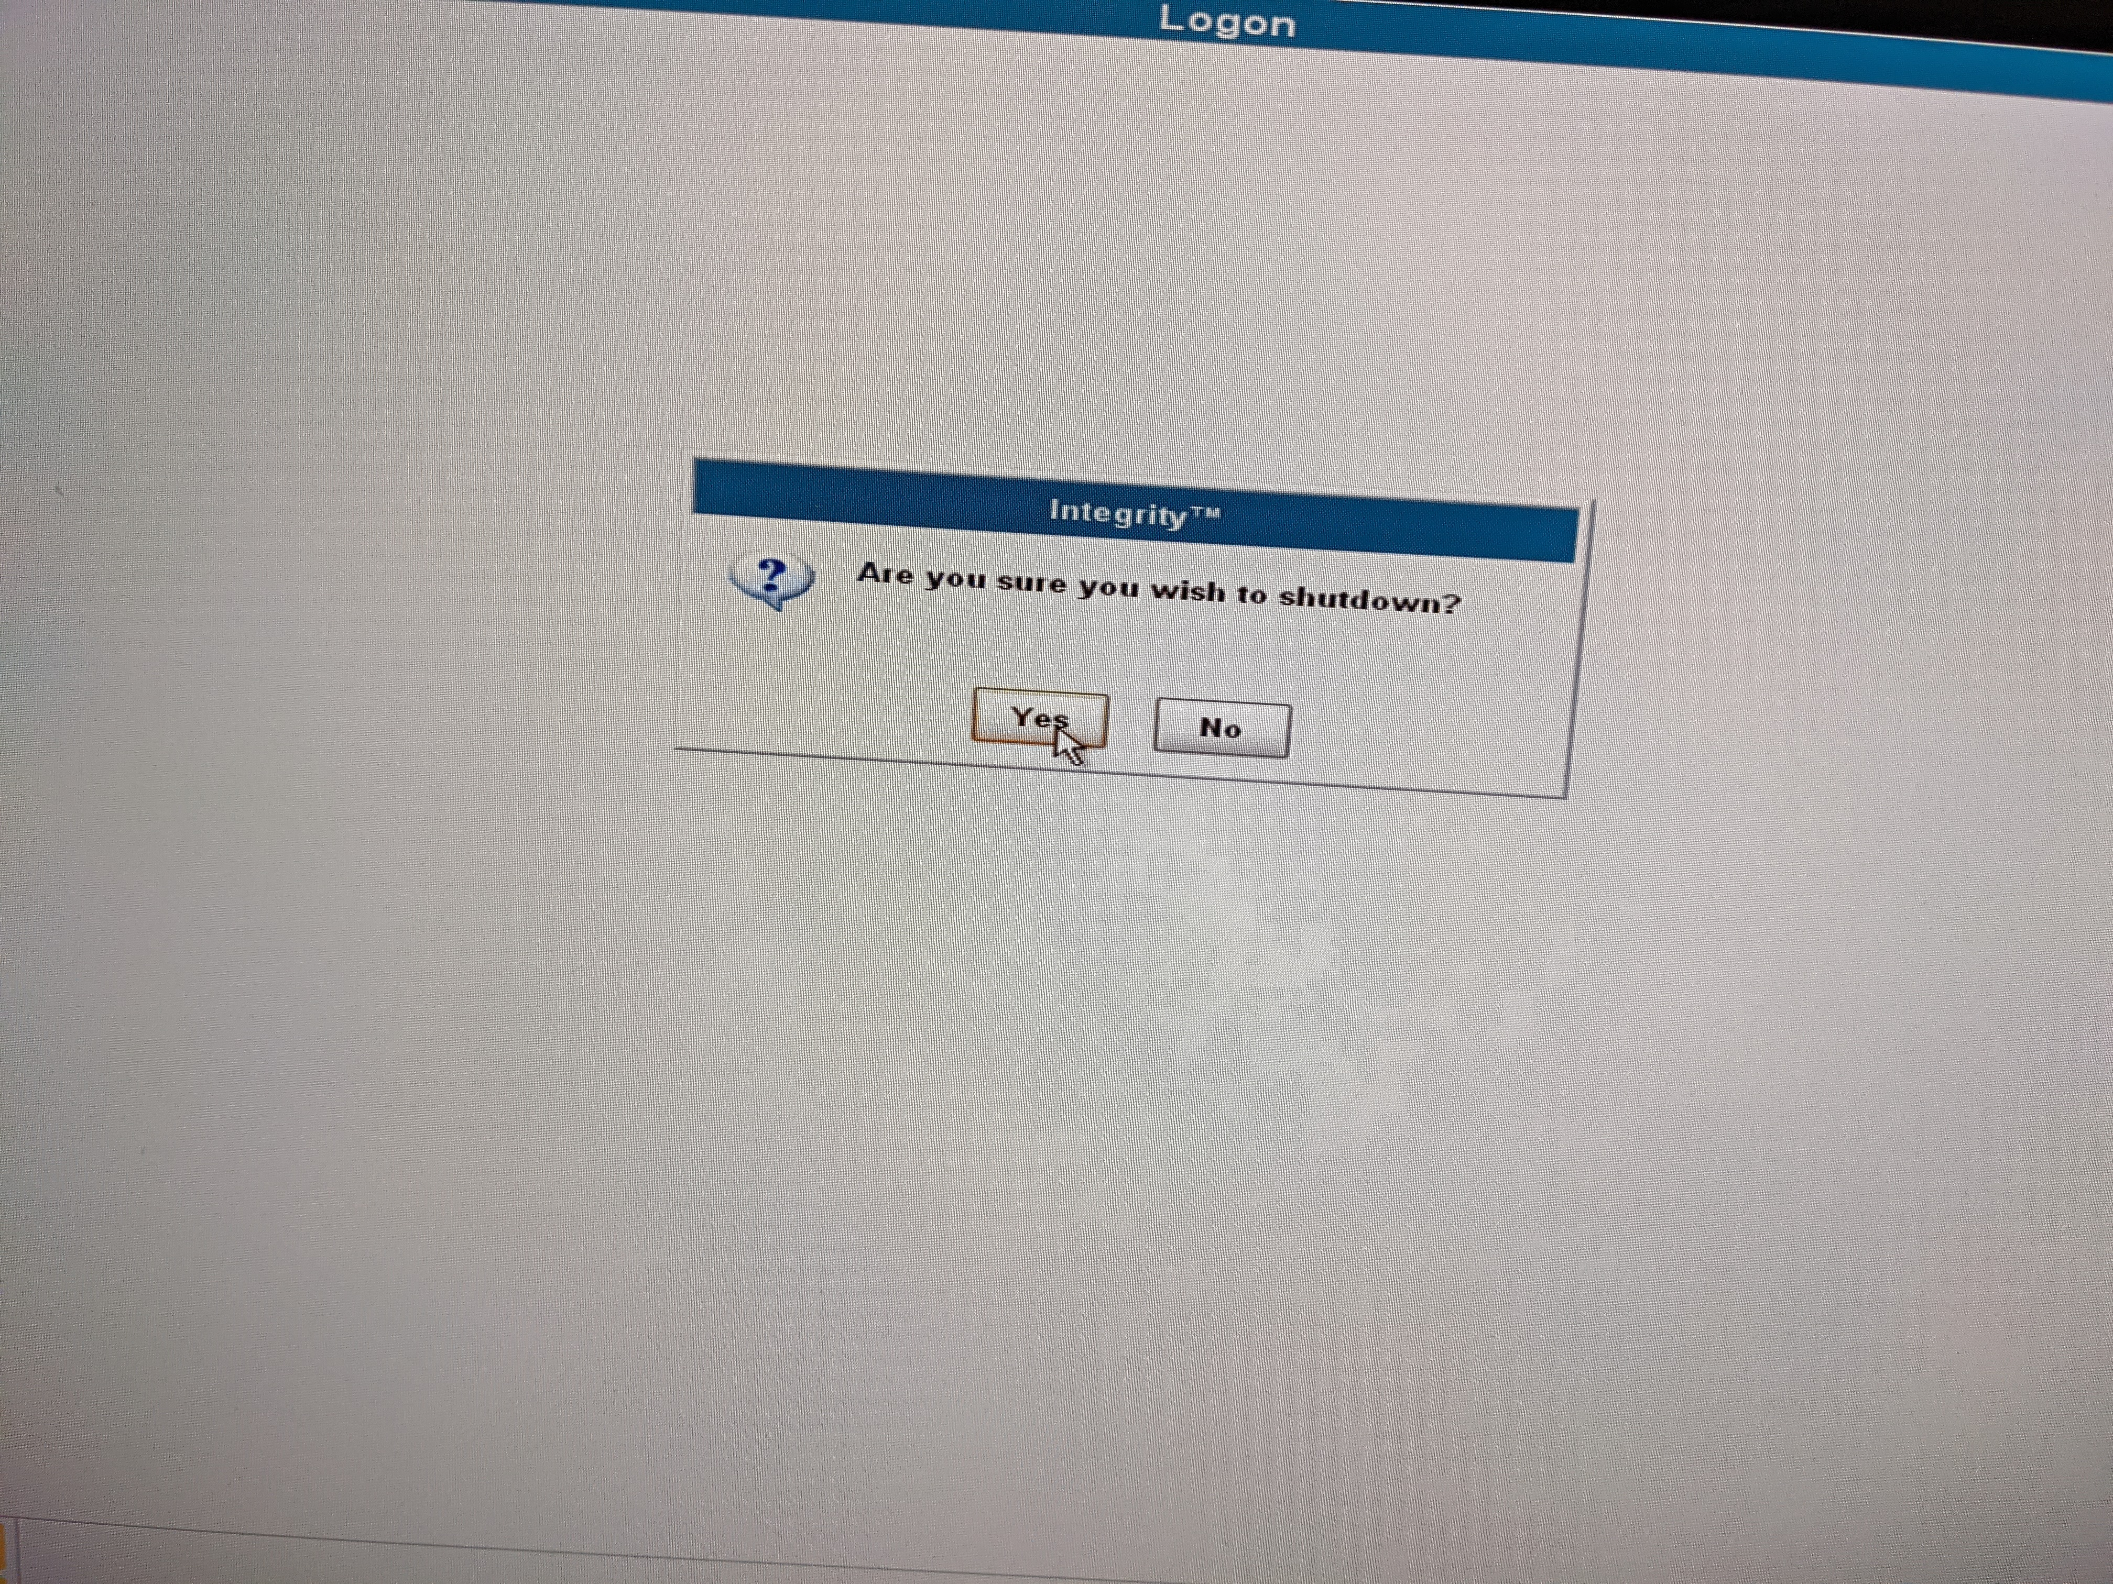

* 1. If the MLCs could not be parked:

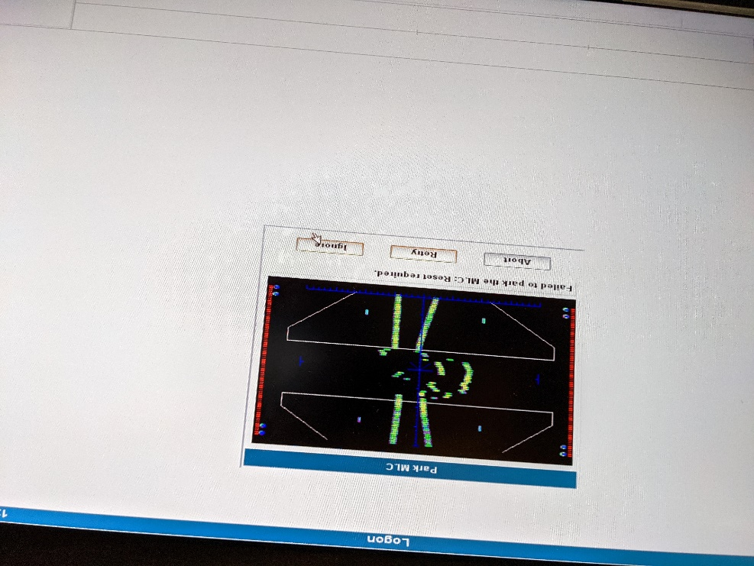

* + 1. Try resetting the linac motors.
       1. Reset from the console.

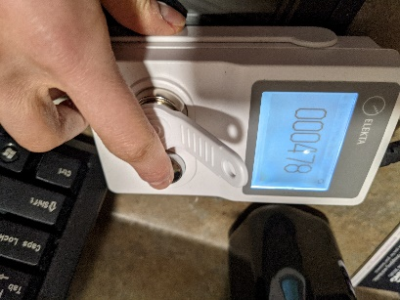

* + - 1. Reset in the room.

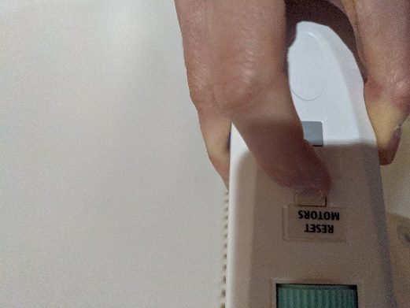

* + 1. If restarting does not resolve the error:
       1. Click **Ignore**.

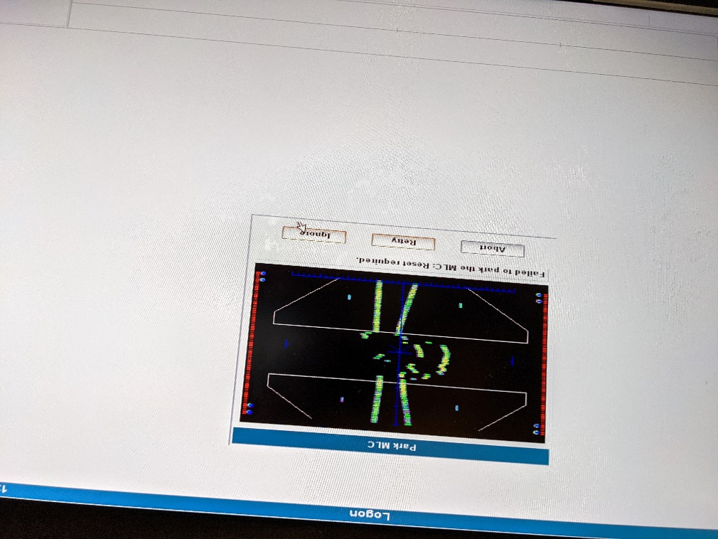

* + - 1. If you are not a physicist, inform a physicist of the error.
      2. If you are not a therapist, leave a sticky note on the monitor saying that the MLCs could not be parked. There are sticky notes in the leftmost top drawer at the E1 console.

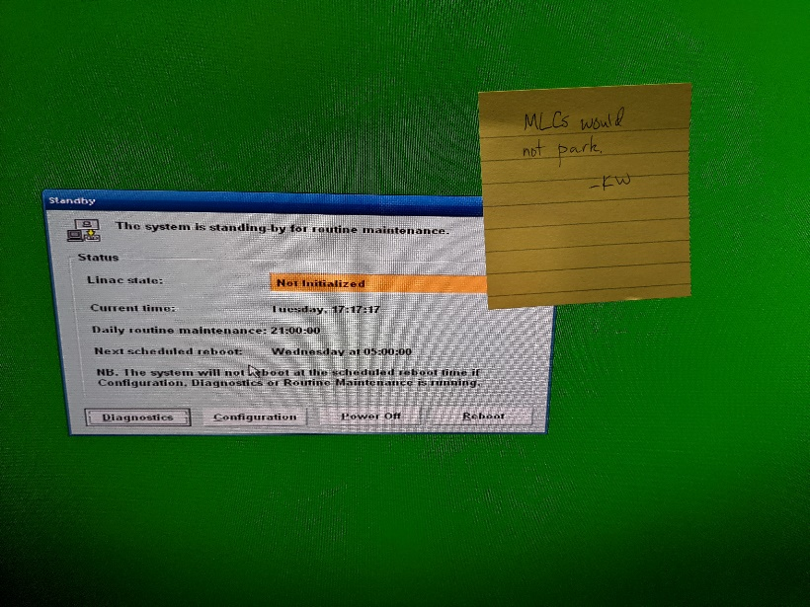

* 1. Wait until the screen turns green.

If it is Friday, shut down the computer.

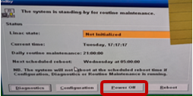

1. Turn off in-room monitor. It should look like this after the previous steps have been completed:

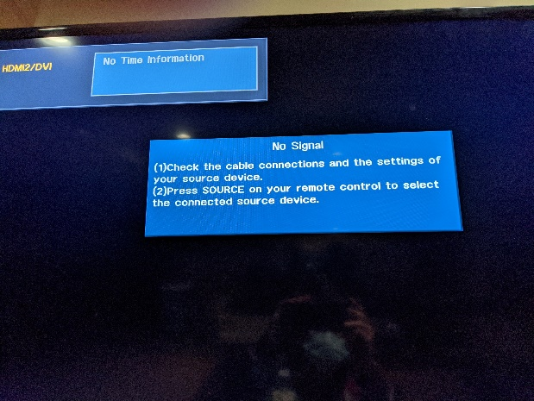

* 1. Press the power button on the bottom of the monitor, to the right.

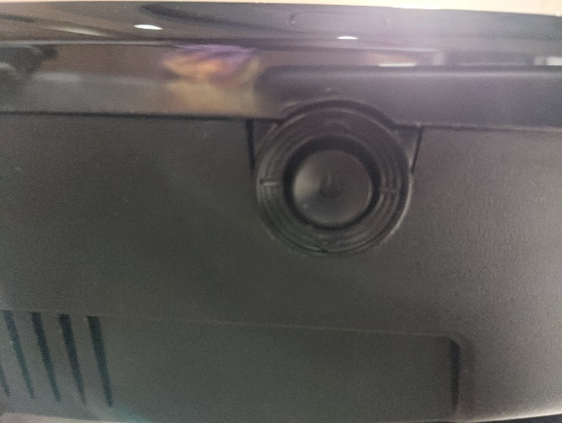

You should see a menu:

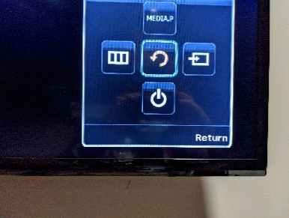

* 1. Move the power button to select the power option.

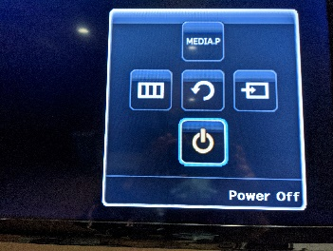

* 1. Press the power button to turn off the monitor.